**SRM Institute of Science and Technology**

**College of Engineering and Technology**

**DEPARTMENT OF ECE**

**SRM Nagar, Kattankulathur – 603203, Chengalpattu District, Tamilnadu**

**Academic Year: 2022-23 (Odd)**

**Question Bank : Unit 2 Date: 06/09/2022**

**Course Code & Title: 18ECC301T - Wireless Communications Year & Sem: VII**

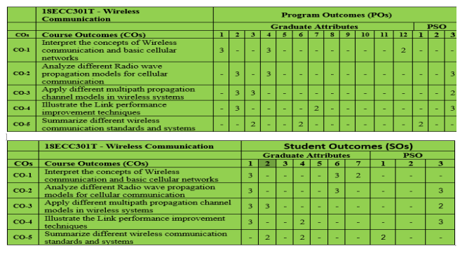

**UNIT II**

**MOBILE RADIO WAVE PROPAGATION (LARGE SCALE FADING)**

**PART – B**

| **S.No** | **Answer ALL Questions** | **CO** | **BL** | **PO** |
| --- | --- | --- | --- | --- |
| 1 | What are the propagation mechanisms of EM waves? | 2 | 2 | 2 |
| 2 | What is the significance of propagation model? | 2 | 2 | 2 |
| 3 | When does large scale propagation occur? | 2 | 2 | 2 |
| 4 | Define coherence time & EIRP | 2 | 2 | 4 |
| 5 | What is Brewster angle? | 2 | 2 | 4 |
| 6 | Mention some outdoor propagation models? | 2 | 2 | 2 |
| 7 | What are merits and demerits of Okumara’s model? | 2 | 2 | 4 |
| 8 | List the advantages and disadvantages of Hata model? | 2 | 2 | 4 |
| 9 | Find the far field distance for an antenna with maximum dimension of 2m and operating frequency of 1 GHz | 2 | 3 | 4 |
| 10 | State the propagation effects in mobile radio. | 2 | 2 | 2 |
| 11 | Write the effects of fading. | 2 | 2 | 2 |
| 12 | Write notes on Cell coverage area. | 2 | 2 | 2 |
| 13 | What is Shadow fading? | 2 | 2 | 2 |

**PART – C**

| **S.No** | **Answer ALL Questions** | **CO** | **BL** | **PO** |
| --- | --- | --- | --- | --- |
| 1 | 1. Explain two-ray ground reflection model in detail. | 2 | 3 | 2 |
| 2 | 2. Explain free space propagation model with suitable expressions. | 2 | 3 | 2 |
| 3 | 3. Explain the advantages and disadvantages of the two ray ground reflection model in the analysis of path loss ii) In the following cases tell whether the two ray model could be applied and justify why or why not Case (i) : h1=35m, hr=3m, d=250 m case (ii) h1=30m, hr=1.5m, d=450 m iii)Prove that in the two tray ground reflection model d =d’’- d’=2hthr/d | 2 | 3 | 4 |
| 4 | 4. If a transmitter produces 50 watts of power, express the transmit power in units of (a) dBm, and (b) dBW. If 50 watts is applied to a unity gain antenna with a 900 MHz carrier frequency, find the received power in dBm at a free space distance of 100 m from the antenna, What is Pr (10 km)? Assume unity gain for the receiver antenna. | 2 | 4 | 4 |
| 5 | 5. A mobile is located 5 km away from a base station and uses a vertical λ/4 monopole antenna with a gain of 2.55 dB to receive cellular3radio signals. The E-field at 1 km from the transmitter is measured to be10-3 V/m. The carrier frequency used for this system is 900 MHz. | 2 | 3 | 4 |
| 6 | (a) Find the length and the gain of the receiving antenna. (b) Find the received power at the mobile using the 2-ray ground reflection model assuming the height of the transmitting antenna is 50 m and the receiving antenna is 1.5 m above ground. | 2 | 3 | 4 |
| 7 | 6. Explain the various types of outdoor propagation model | 2 | 2 | 2 |
| 8 | 7. Explain in detail the three significant wave propagation mechanisms that affect the propagation of EM waves | 2 | 2 | 2 |
| 9 | 8. Describe the empirical path loss model and simplified path loss model with suitable expressions. | 2 | 3 | 2 |
| 10 | 9. Discuss the Okumara and Hata outdoor propagation model in detail. | 2 | 3 | 4 |
| 11 | 10. Explain the free space path loss model, and describe the following a).log-distance path loss model, b).log-normal shading path loss model c). determination of percentage of coverage | 2 | 2 | 4 |